OUTLINE

TITLE OF THE PROJECT

NAME OF THE APPLICANT LOCAL / REGIONAL GOVERNMENT

CITY / COUNTRY

1.1. Title
NOTE. You should only write the title of the policy, programme or project.

1.2. Brief description
NOTE. You should present the overall policy, programme or project, in a maximum of 300 words.

1.3. Duration
NOTE. It is necessary to explain the start and end dates of the policy, programme or project, indicating if it is a completed initiative, one in progress, or otherwise indicating its timeline.
Start date

End date (only if it has finished)

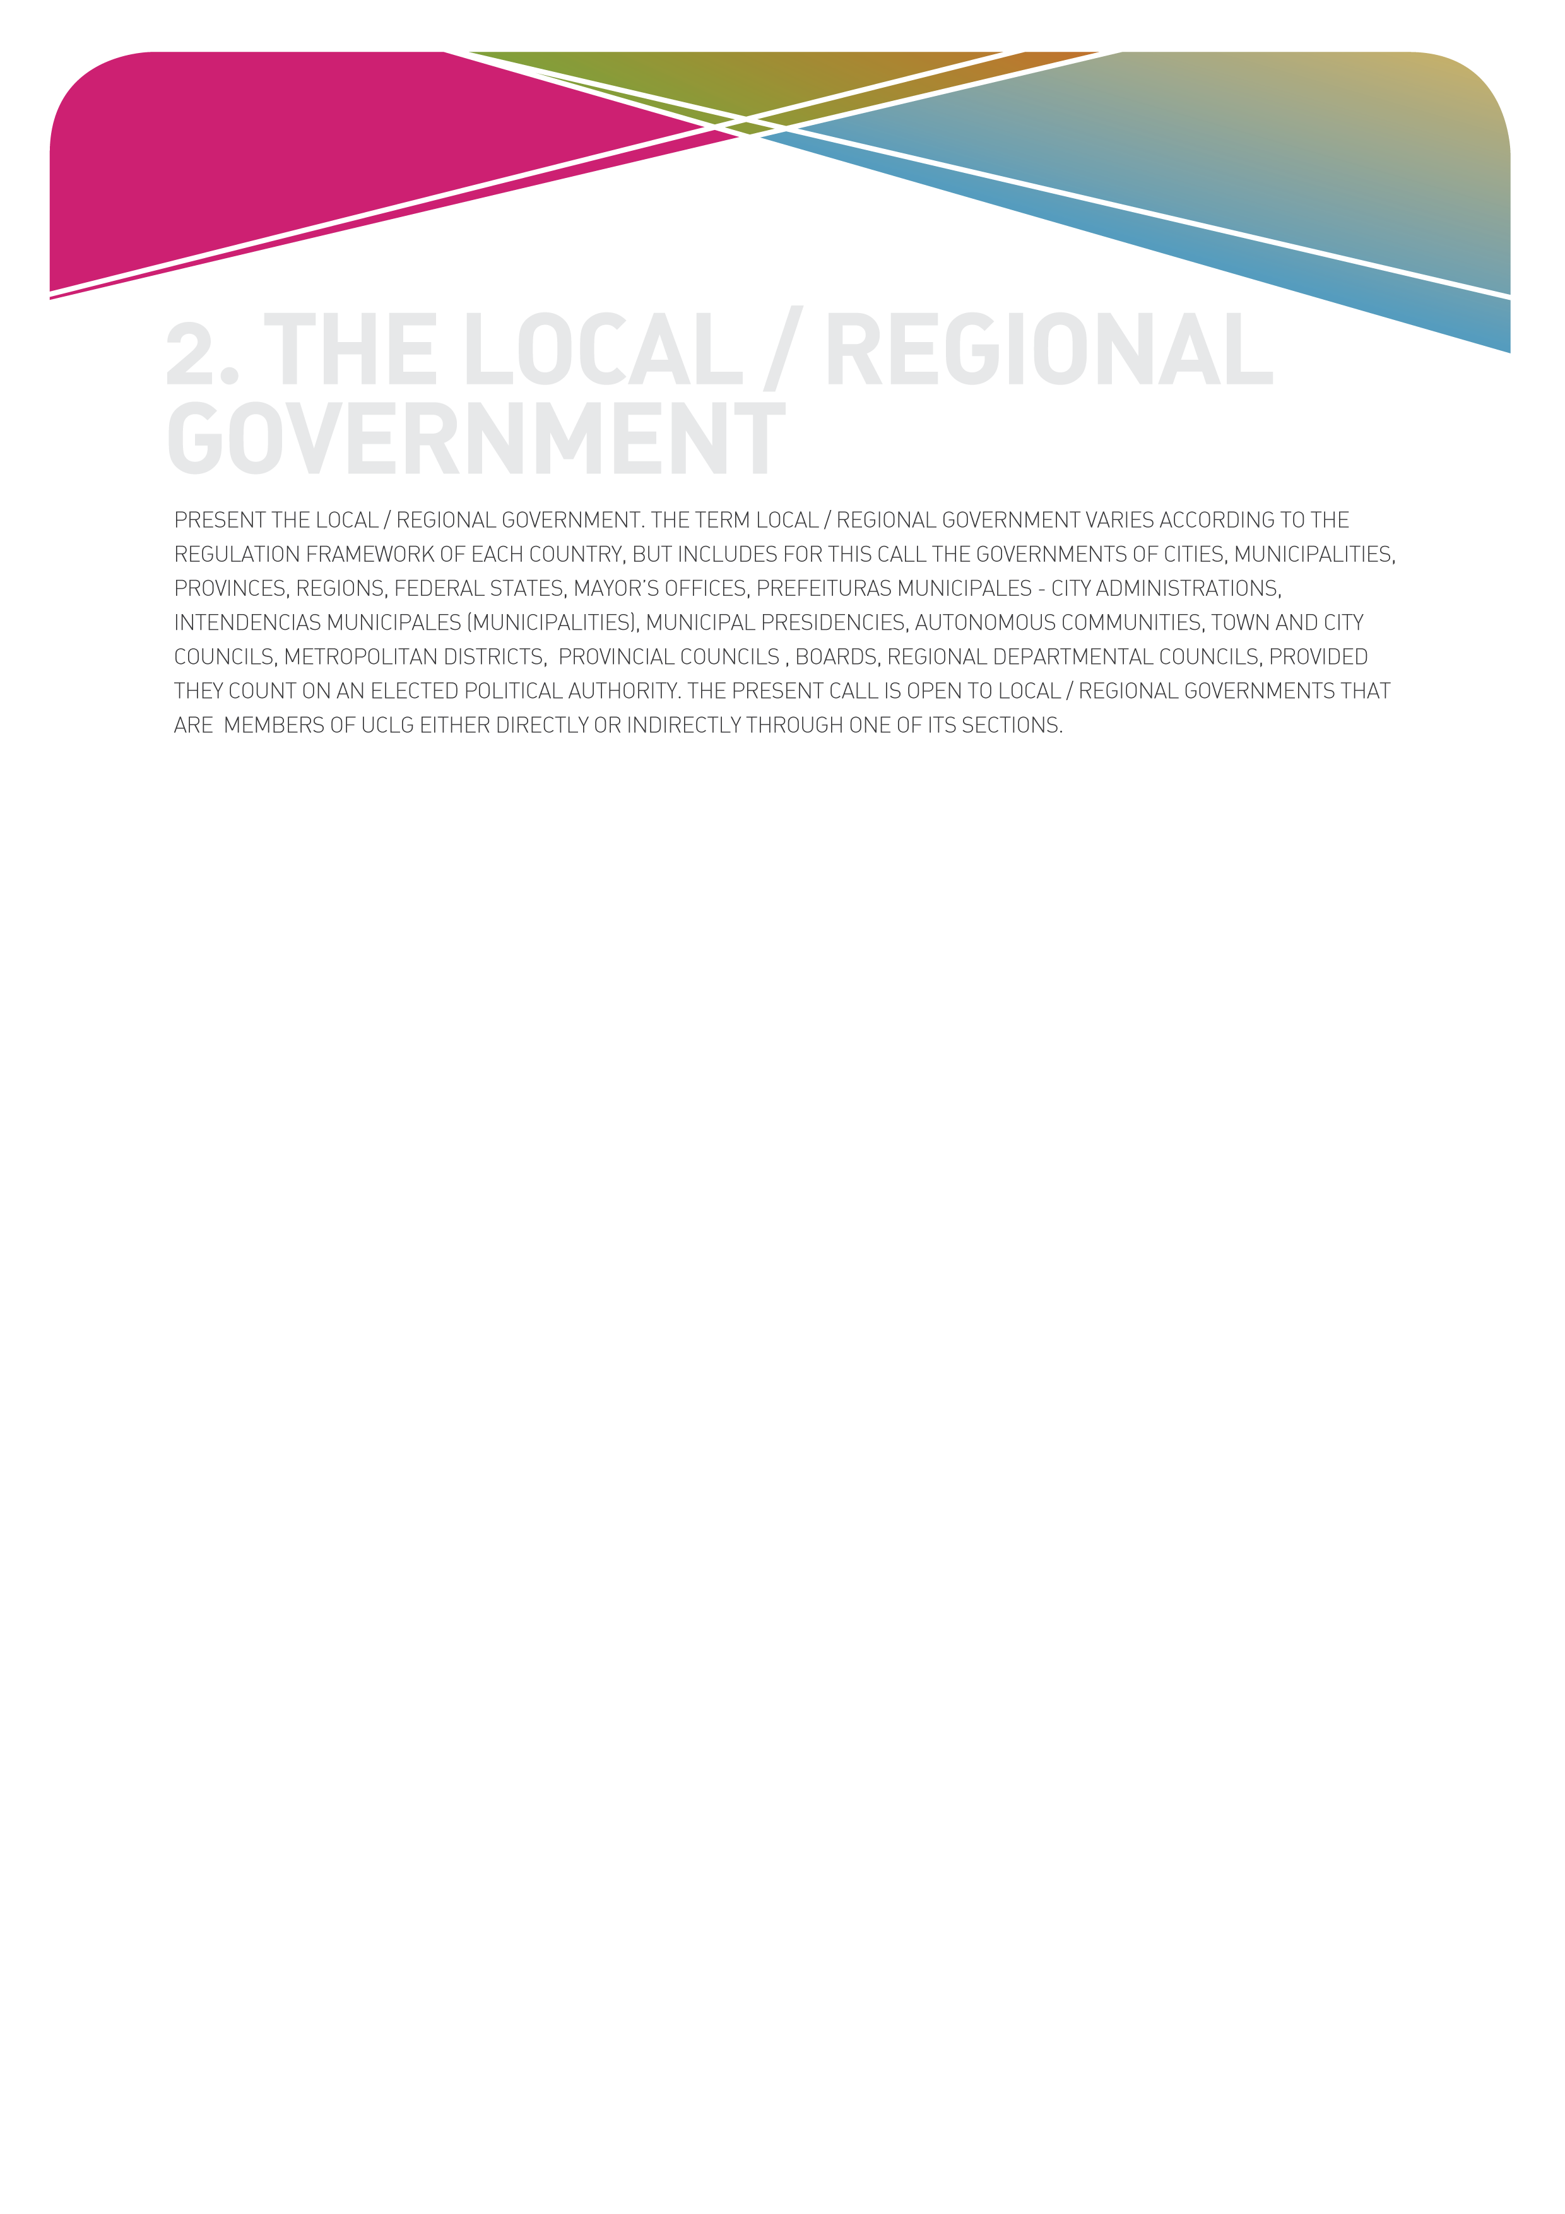

2.1. Name of the applicant local /regional government

2.2. Details of the Mayor or Head of the local/regional government
NOTE. Write here the details of the mayor or head of local/regional government. These details should correspond exactly to the details that appear in the letter of presentation or annex A.
Name
Position
Address
City
Country, province and state
Telephone
Fax
E-mail
Website

2.3. Details of the person responsible for the bid
NOTE. The person responsible for the bid is the person that has written all the sections of this form and knows the bid in depth. It should be an executive person in the organisation chart of the local/regional government, and who will be the main contact person with the organisers of the Award.
Name
Position
Address
City
Country, province and state
Telephone
Fax
E-mail

3.1. Description of the city / territory where the project has been developed
NOTE. You should present the situation in the city / territory where the project was developed, in a maximum of 200 words.

3.2. The cultural policies in your city
NOTE. Explain especially the general framework of local cultural policies, in such a way that you provide evidence that the policy, programme or project that is the object of this application is coherent with them. You are requested to explain how local cultural policies are formulated. We ask you to make the description clear and to include critical elements, including the weaknesses and advantages of the relevant policy, in a maximum of 400 words.

3.3. Specific context
NOTE. You should present the background to the policy, programme or project, in a maximum of 400 words.
The explanation should respond to these questions:
- Who started the project? Why?
- What need, problem or gap did it aim to address?
- In what way is the programme or project coherent with the development policies of your city?

3.4. Relation of the policy, programme or project with the Agenda 21 for culture
NOTE. You should give evidence that there exists a relation between the project and the Agenda 21 for culture (see www.agenda21culture.net). You should describe this precisely, in a maximum of 400 words.

4.1. General aim
NOTE. There should only be one general aim. In this section you should explain in a simple, very synthetic and concise way, what the general aim of the policy, programme or project is, in a maximum of 100 words.

4.2. Description
NOTE. In this section you should describe the policy, programme or project. The maximum length is 1,000 words. As general guidance, you may consider the following elements:
- Specific goals
- Main actions carried out
- Phases
- Budget
- Obstacles faced in the implementation
- Results

4.3. Partner entities
NOTE. Often a project is developed in collaboration with civil society entities or Non-Governmental Organisations. If this is the case, in this section you should explain the details of this collaboration (e.g. at which stages of the project it takes place, what difficulties have been encountered, etc.) and the role played by each partner. The maximum length is 200 words.

4.4. Other partner governments
NOTE. Often a project is developed in collaboration with other levels of government (regional / federal / national). If this is the case, in this section you should explain the details of this collaboration (e.g. at which stages of the project it takes place, what difficulties have been encountered, etc.) and the role played by each partner. The maximum length is 200 words.

4.5. Beneficiary population
NOTE. Here you should describe which groups / population have benefitted from the project, directly or indirectly, how they have been involved in the project and at which stages (design, implementation, evaluation) and how they have benefitted. Maximum length is 300 words.

5.1. Direct impact
NOTE. Give evidence of the impact of the project for the local government, for the cultural sector and for the city as a whole. You can respond by thinking, respectively: “How has the local government changed as a result of the project?” “How have cultural actors in the city changed as a result of the project?” and “How has the city in general improved after the project?”. The answers should be no longer than 100 words in each of the three sections.
A. Impact on the local government

B. Impact of the project on the culture and the cultural actors of the city / territory

C. Impact of the project on the city / territory and its population

5.2. Transversal impacts
NOTE. You should give evidence of the transversal impacts of the project (if there were any) in the economic, social and environmental fields, in terms of human rights and with regard to gender equality. Answers should be of a maximum of 250 words.

5.3. Evaluation
NOTE. You should explain whether any evaluation mechanism for the policy, programme or project has been planned. In this case, the methodology and indicators applied as well as the results obtained should be described. Answers should be of a maximum of 200 words.

5.4. Key aspects
NOTE. You should describe the key aspects which serve to explain, in your view, the effectiveness of the policy, programme or project that is the object of this application. Answers should be of a maximum of 200 words.

5.5. Continuity
NOTE. Provide information about the way in which the local government has given continuity to a completed project, or foresees giving continuity to a project in progress. You can give details about the organisation, technical and financial dimension of this continuity in a maximum of 200 words.

6.1. Local and international promotion
NOTE. Describe the actions of local and international promotion foreseen by the local government, if the city is awarded the prize, in a maximum of 300 words.
Local and international promotion

6.2. Local implementation of the Agenda 21 for culture
NOTE. In this section you should describe the actions for the strengthening of the local implementation of the Agenda 21 for culture, if the city is awarded the prize, in a maximum of 200 words.
Strengthening of local implementation of the Agenda 21 for culture

6.3. Budget
NOTE. In broad headings, include the details of the budget dedicated to each of the actions and sub-actions of sections 6.1. and 6.2. All items above Euro 5,000 should be detailed.
Budget

OBLIGATORY ANNEX
A letter of presentation signed by the mayor or head of the government who will lead the whole bid.
A. Letter of presentation of the mayor, with free structure and contents, although one paragraph should be dedicated to summing up the project (summarising section 1), another should outline how the city will use the funds of the Award (summarising section 6) and another paragraph that mentions the membership in UCLG.

OPTIONAL ANNEXES
(List here the complementary documents included with your bid, a maximum of 3 documents, either text, videos or multimedia).
B.
C.
D.

