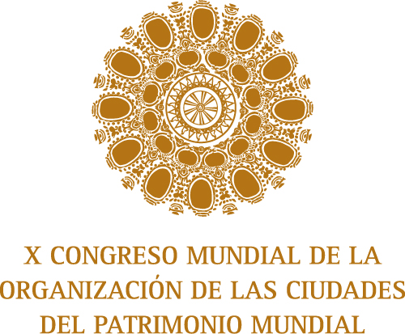
1. PERSONAL INFORMATION
Registration date : *

Name:*

Surname: *

Organization: *

Work Address :*

City: *

State - Province:*

Post Code :
Country: * *

Telephone: * | Country Code: City Code: No.:
Fax : * | Country Code: City Code: No.:
Email : *

Contact in case of emergency during the event :*

Emergency phone number : * | Country Code: City Code: No.:
Permission to share my data and images for films and photographs

2. REGISTRATION FEES:
PARTICIPANT | On site
OWHC Member | 450 USD
OWHC Non Member | 600 USD

* Values do not include taxes
ACCOMPANYING PERSON | On Site
Attendant | 400 USD

* Values do not include taxes, The cost includes turist activities from May 9 to 11
Attendant’s name 1: *
Attendant’s surname 1: *
Attendant’s name 2: *
Attendant’s surname 2: *

3. SERVICES
Language you prefer : * | Spanish: | English: | French:
Do you need simultaneous interpretation? | Yes: | No:

4. CANCELLATION POLICIES
- The cancellation of the registration should be received in writing until August 3, 2009. It must be sent to the Congress Secretariat through email to inscripciones@ocpmquito.org
- The value of the registration will be reimbursed with a 25% penalty for administrative expenses if the communication is sent before August 3, 2009. After this date, the value of the registration is NOT REIMBURSABLE. (*) .
*The values will be reimbursed after the Congress
5. METHOD OF PAYMENT
5. METHOD OF PAYMENT
Cash or Check |  | The payments in cash and check will only be received at Coordinamos, Av. Colón E 4 -105 y 9 de Octubre, Edificio Solamar, Piso 1, Oficina 102. Quito – Ecuador. The check should be made to the order of Fondo de Salvamento  The moment when the money is received, an invoice will be issued; this document confirms that the registration is confirmed.  .
Bank Transfer |  | INTERMEDIARY BANK  BANK’S NAME : Bank of America  BENEFICIARY: Fondo Latinoamericano de Reservas FLAR (FLARCOBB)  ACCOUNT NUMBER : 6550139851  SWIFT CODE: BOFAUS3N  BENEFICIARY BANK  BANK’S NAME: Banco Central del Ecuador  ACCOUNT NUMBER: 101602  SWIFT CODE: BCENECEQ 100  BENEFICIARY’S INFORMATION :  NAME: MUN. QUITO – FONDO PATRIMONIO CULTURAL  ACCOUNT NUMBER: 01220026  ADDRESS: Venezuela 914 y Chile Edificio Pallares Piso 3  TELEPHONE: + 593 2 2584961  TRANSFERENCIA EXPENSES MUST BE ASSUMED BY THE PARTICIPANT
Credit Card |  | To pay by credit card, download the respective form and send together with this registration form
Comments on your payment method

